NOTICE OF PROPOSAL TO CREATE AGRICULTURE PROTECTION AREA
Reshlar 2025
September 24, 2025

Ag protection allows certain protections to landowners from zone changes. They can still take advantage of all uses in their underlining zone and develop as they wish as long as it is permitted.

Notice is hereby given that a proposal has been filed with the Utah County Commission to establish the Reshlar 2025 agriculture protection area in Section 27, Township 8 South, Range 2 East, Salt Lake Base and Meridian, with a total area of 20.52 acres. The proposal will be open to public inspection at the Community Development Office, 51 South University Ave, Room 117, Provo, Utah, (801) 851-8343, during regular office hours. Any person or entity affected may file a written request for modification to add or remove land from the proposal or written objections to the proposal with the County Commission within 15 days of the date of this notice. The County Commission will submit the proposal to the Agriculture Protection Area Advisory Board and to the Planning Commission for review and recommendations. The County Commission will schedule a public hearing to discuss and hear public comment of the proposal to create the agricultural protection area, requests for modification, objections, and the recommendations of the Agriculture Advisory Board and Planning Commission. A Public Hearing will be scheduled at a future date, and an additional notice will be posted and mailed.

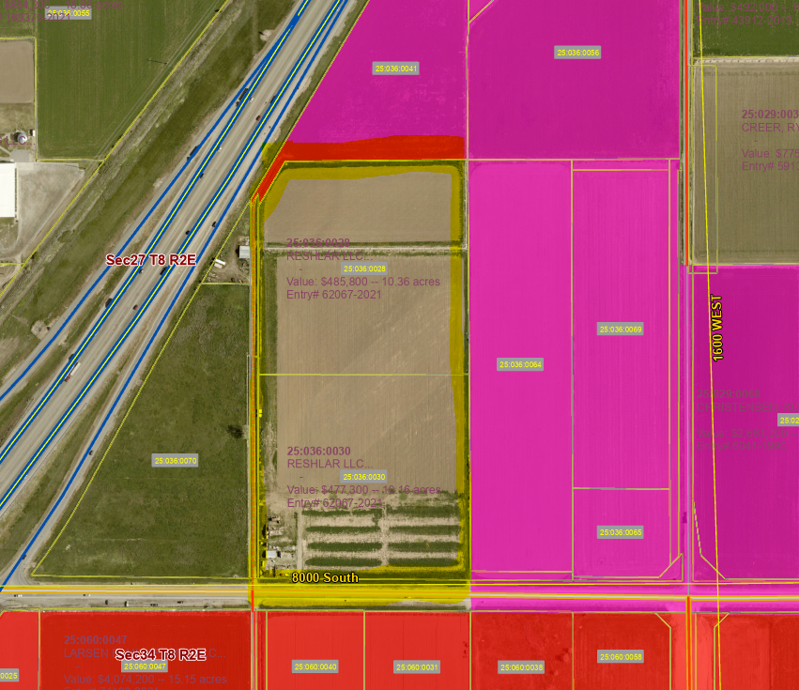
Purple – Spanish Fork City
Red – Salem City
Highlight – Proposed Agriculture Protection Area

